DevSecOps Training in Real Time : Phase - I

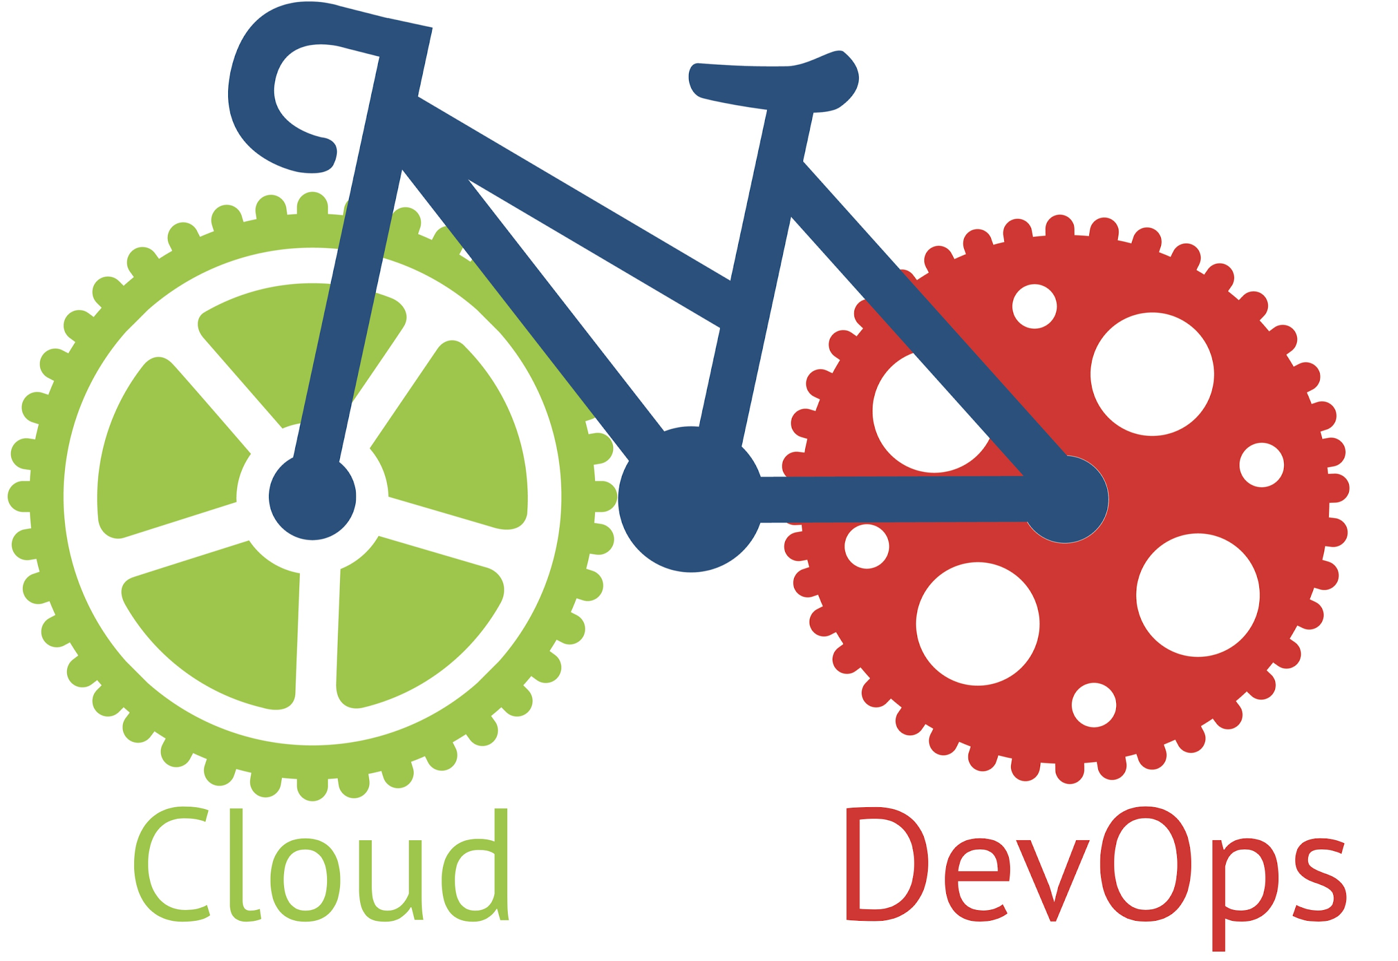

Duration of course: 70 Hours(2 Months)

by SREEHARSHA VEERAPALLI

Training Available in Telugu and English.

[mavrick202@gmail.com](mailto:mavrck202@gmail.com) [sreeharshav@mavricktrainings.com](mailto:sreeharshav@mavricktrainings.com)

Syllabus:

**Module 1: Shell Scripting**

* Introduction and use cases of DevOps.
* Understanding DevOps lab infrastructure on AWS.
* Course overview.
* Introduction to Linux Shell Scripting.
* Creating shell scripts for day-to-day activities.
* Understanding IF, WHILE and FOR statements in Shell Scripting.
* Introduction to Powershell Scripting.
* Understanding Noun-Verb usage in Powershell.
* Installing Powershell modules and using them.
* Understanding IF, WHILE and FOR statements in Powershell.
* Creating scripts for regular user management and administration.

**Module 2: Python Fundamentals & FastAPI Basics**

* Shell Scripting vs Python?
* Installing Python on Windows and install Python Base Modules
* Configuring Python Virtual Environment and Install project specific modules.
* Python Data Structures.
* Working with Python Environment Variables.
* Python IF & ELSE Conditions.
* Python For & While Loops.
* Working with modules.
  + os
  + sys
  + json
  + uuid
  + faker
  + requests
  + ipython
  + dotenv
  + boto3
* Working with POKEMON API with requests module.
* Working with Boto3 Module.
* Python Functions.
* Error Exceptions in Python.
* Understanding FastAPI.
* Deploy FastAPI and configure Jinja2 and Routers.

**Module 3: Version Control with Git & GitHub**

* Version Controls and its significance
* Introduction to Git version control application
* Git Repositories & GitHub Authentication
* Adding, Committing, Renaming & Deleting files
* GitHub Branches, Merging & Webhooks
* Understanding stash, diff, rebase, fetch, pull, push.
* Performing Git Operations with Terraform Code on Azure.

**Module 4: Terraform & Packer**

* Introduction to Infrastructure As A Code.
* Differences between CloudFormation, Azure ARM & Terraform.
* Basics of HashiCorp Terraform
* Configuring Terraform Lab Platform
* Understanding Terraform files
* Terraform Providers, Variables & States, Locals.
* Using Terraform Functions for Terraform Productivity.
* Configuring Remote state using AWS Simple Storage Service(S3)
* Understanding Terraform Functions.
* Creating Terraform Modules.
* Creating Workspaces in Terraform Enterprises(TFE)
* Introduction to Packer
* Create AWS AMI using Packer.
* Integration of GitHub, Packer & Terraform with Jenkins.

**Module 5: Docker & Docker Swarm Orchestration**

* Introduction to Containers & Docker
* Docker architecture & Docker repositories
* Pull, Create & Upload Docker images
* Using Dockerfile and Docker Compose
* Understanding Docker Networks
* Understanding Docker Volumes
* Creating Docker cluster using Docker Swarm
* Docker Swarm Stacks and Container Placement
* Docker Swarm Node Availability
* Docker Swarm Rolling Updates
* Docker Swarm secrets and Container healthcheck
* Introduction to Kubernetes
* Deploying PODS, Services,Deployments.

**Module 6: Ansible**

* Introduction to Ansible.
* Differences between Ansible vs Puppet Vs Chef.
* Understanding Ansible Architecture.
* Configure Ansible Lab Platform.
* Integrating Ansible with Terraform & Packer.
* Creating & Using Ansible Playbooks.
* Understanding & Using Ansible Roles.
* Using Ansible Variables & Templates.
* Leveraging Ansible Galaxy for Roles.

**Module 7: Puppet**

* Introduction to Puppet
* Puppet Architecture & Puppet components
* Puppet Master & Client Installation & Configuration
* Puppet Classes and Defined Types
* Puppet manifests
* Puppet Modules
* AWS Puppet use cases

**Module 8: Jenkins**

* Introduction to Jenkins
* Install & Configure Jenkins
* Features & Master-Slave Architecture of Jenkins.
* Configuring Slaves in EC2 and Docker Containers.
* Configure Jenkins Job, RBAC, Pulgins.
* Creating and managing Scripted and Declarative Pipelines.
* Creating multi branch pipelines with Jenkins Blue Ocean.
* Configuring CI/CD Pipeline.
* Integrating with Maven & JFrog for Springboot Application.
* Integrating With Sonarqube for Code Quality, Code Coverage and Bugs.
* Integrating Jenkins with AWS, GitHub & Docker.
* Configure Jenkins Notifications For Slack.

**Module 9: Azure DevOps**

* Introduction to Azure DevOps and Agile terminologies.
* Creating User Stories,Issues, Epics, Kanban Boards.
* Creating Repositories, Importing Code and Branching with Azure DevOps.
* Creating Build Pipelines and Integrating with Azure, AWS Storage.
* Creating and Pushing Docker Images using Azure DevOps.
* Azure DevOps Builds and Artifacts.
* CI/CD with Azure DevOps using Release Pipelines.
* Integrating Terraform with Azure DevOps.
* User Management for Azure DevOps using Azure Active Directory.
* Azure DevOps Custom agent pools & Deployment Groups.
* Integrating with Maven and JFrog.
* Updating POM File for Spring Boot Applications.

**Module 10: Security Tools**

* Version Control Security with GitLeaks
* Introduction to Static Code Analysis.
* Installing Sonarqube and performing analysis.
* Terraform Code Security analysis with Checkov & tfsec.
* Installing & Configuring HashiCorp Vault.
* Protecting Secrets with HashiCorp Vault.
* Container Image Security Scanning with Trivy.
* Dynamic DAST with OWASP ZAP testing.
* Protecting Configuration Secrets with Ansible Vault.

**Module 11: Build & Monitoring**

* Installing maven.
* Maven lifecycle & Performing builds.
* Understanding Maven Build LifeCycle.
* Integrating with JFrog for Maven Deploy.
* Introduction to Prometheus Monitoring.
* Installing Prometheus and configuring Linux Server node exporter.
* Creating Grafana Dashboards.
* Understanding Alert Manager.